Supporting children and young people with worries about COVID-19

Advice for parents, carers and people that work with children and young people | This is a time of uncertainty and a lot of children and young people will be feeling anxious and worried about what is going on. This is a normal response to the situation and below we offer some advice about what adults can do to help and support children and young people.  There is a lot of information becoming available - this is great but may also be confusing, so we have pulled together some advice and some of our favourite links in to one place. We hope this will be helpful.  Given that the situation is changing rapidly at the moment we
will make updates from time to time which you will be able to find here: https://emergingminds.org.uk/resources/

Look after yourself
It is understandable if you are feeling anxious and worried yourself at the moment and you may have some very difficult challenges to negotiate. Do look out for things that help you to cope. This will make it much easier for you to be able to respond in the way that you want to when talking to children and young people.
There is some useful information aimed at adults here:

https://www.psy.ox.ac.uk/covidmental-health -19-our-

https://www.rethink.org/news-and stories/blogs/2020/03/managing-your mental-health-during-the-coronavirus outbreak/

https://www.mind.org.uk/information support/coronavirus-and-your-wellbeing/

Keeping healthy habits
Where it is possible to do so, try to maintain normal routines as much as possible- for example, in relation to eating, sleeping, studying and playing or downtime. Routines help children and young people to feel safe. Getting outside in nature can also be beneficial. There is evidence that contact with nature boosts mood so, as long as medical advice permits, try to spend time outside with children and young people. If they are not able or do not want to leave the house, encourage them to get some exercise at home – there are lots of free apps or videos available on YouTube.

Watch out for getting caught in vicious cycles
There are some behaviours that it might be easy to get in to at this time that can make anxiety worse in the long run, such as:
- Avoiding things (e.g., a parent sleeping in the bed with their child instead of them sleeping on their own)
- Withdrawing from other people
- Constantly googling for information
- Spending a lot of time talking about worries
- Being on the lookout for danger
- Checking (e.g., looking at news updates a lot)
- Being in your head a lot thinking about things rather than fully doing things
- Washing hands at a level that goes well beyond the medical advice

Be on the lookout for these and other behaviours, and encourage children and young people to notice what helps (not just in the immediate short-term) and what ends up making them feel more anxious. Later on, we’ll give you some ideas about how you might help them to deal with these behaviours in order to break any vicious cycles that they might have inadvertently ended up in.

Responding to children and young people
Children and young people will also be looking to the adults around them for clues on how they should be responding and whether they should be worried so do try to keep your responses in check during conversations with children and young people. This is not to say that you need to hide your anxiety, to the contrary, it is important to help children recognise that a certain amount of anxiety and stress is normal and to see how to deal with it (e.g. “When I am worried about this I like to call my friend, shall we call your friend to talk to them?”, or “When I’m worried I like to watch a funny TV programme to take my mind off it, what TV programme would you like to watch”?). It is ok for them to know that adults worry too but they will feel more scared and find it harder to share their worries if they see adults feeling overwhelmed.

Talking about worries
It is good to talk about worries and listen to children and young people’s concerns. Try to make time and space for children and young people to talk to you. They won’t always let you know that they want to talk so look out for signs, such as them staying closer to you than usual.

When to talk
It is great if you can talk to children and young people at the time that they raise worries, as clearly they are feeling able to talk at that time. But we know this is not always possible and it is important to talk at a time when both you and they are not stressed, busy or tired. It can also be helpful to try to avoid discussing worries immediately before bed as things often seem scarier and more worrying at bedtime. If children raise worries or concerns at these times let them know that you have heard their worry and that you definitely want to talk to them about it and agree another time to have the conversation (and stick to this plan). Then perhaps come up with some other things that they can switch to thinking about instead of engaging in worrying.

How to talk
Key characteristics of situations that create worry and anxiety are a heightened sense of uncertainty, potential threat, and responsibility, and a reduced sense of control so it is easy to see why our current circumstances are fuelling anxiety. So, in conversations with children it is important to help them to:
- Recognise that is understandable to
feel worried or anxious
- Develop an accurate and realistic understanding of the situation
- Recognise simple, practical things that they can do, but also to be clear about
the limits of their responsibility

Here are some steps that may be helpful:

Be curious and acknowledge their fears and worries
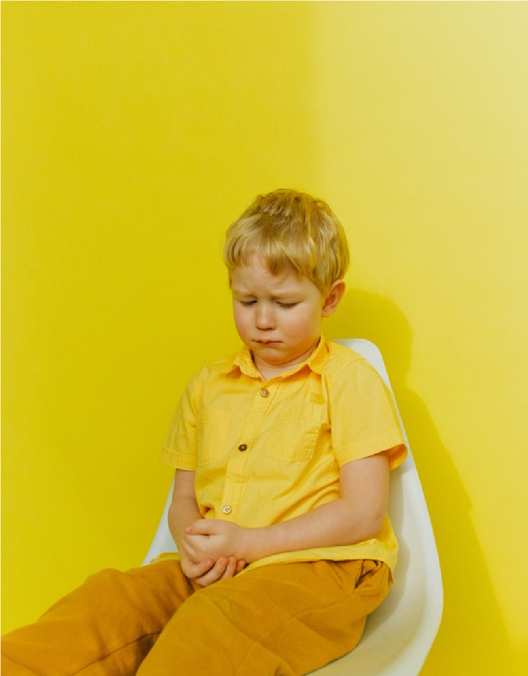
Start with ‘open questions’. These are questions that can’t be answered with a simple ‘yes’ or ‘no’ (e.g. “What makes you feel that way?”; “What have you heard about the virus?”, “What are your worries about this”?).
Older children may have picked up information online or through friends, so do explore what sorts of things they have been hearing. This will all help you to understand any fears and worries that they have.
Acknowledge how their thoughts must be making them feel. Try not to minimise or dismiss worries (e.g. “It will be fine!”, “Don’t be silly”), as this can lead to young people feeling that their concerns are not being taken seriously which may make them reluctant to talk about rather than feel able to come back and share thoughts or ask questions in the future (however silly they may seem). It is also hard to control what thoughts pop into our heads, so rather than saying “Don’t think about it”, encourage them to notice the thought but try not to engage in it (e.g., “There’s the annoying worry thought again, what can you think about instead?”)

Help them to feel understood and that their worries are normal
Acknowledge that it is an anxiety-provoking time for everyone and that it is normal to feel worried. For example, if a child is worried about their grandparents you might say “I can see that you are worried about your Grandma and Grandpa, I am a bit worried about them too” and then follow with points 3, 4 & 5.
Recognise that things will be different for a while and that this might mean they feel disappointed as things they are looking forward to or enjoy doing are cancelled. This disappointment is understandable and ok.

Gently correct any misunderstandings that they may have
After noting their worries and showing that you understand, you can gently share facts to correct any misunderstandings (e.g. a child may think that because the virus is in their town everyone is going to die, you can respond by saying “I can see you’re scared that someone down the road has the virus, and it isn’t very nice knowing someone who lives near us is ill, but that doesn’t mean that we’re going to die and, in fact, most people who get it just get a fever and a cough”).
Keep the conversation fact-based where you can (e.g., that most people get mild symptoms and recover within a few weeks; that pets are not affected). Draw on information from recommended, reliable sources that are appropriate to your child’s age group and research the news together (see links below).
If you don’t know or can’t find the answer, then it is fine to say that you don’t know. There is a lot of uncertainty at the moment and it is impossible to answer some of the questions that young people will ask. Rather than trying to remove all the uncertainty for them and find answers to all of their questions, it can be helpful to explain that there are things we don’t know and that it is ok to not know. You can then reassure children by explaining that the adults around them will take care of them and that scientists and doctors are working hard to find out how best to help.

For younger children
Nanogirl Live has produced a couple of videos explaining COVID-19 and why it is important to wash our hands/ sneeze and cough into our elbows:
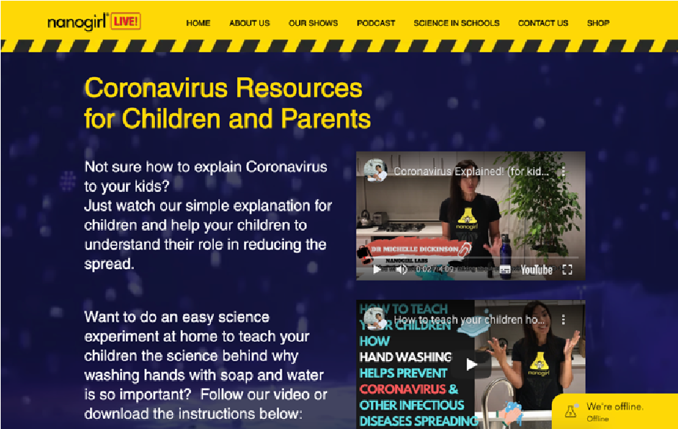
https://www.nanogirllive.co.nz/coronaviru s-soap-experiment

This comic strip provides a visual explanation of the COVID-19 outbreak and what we can do to stop it’s spread:
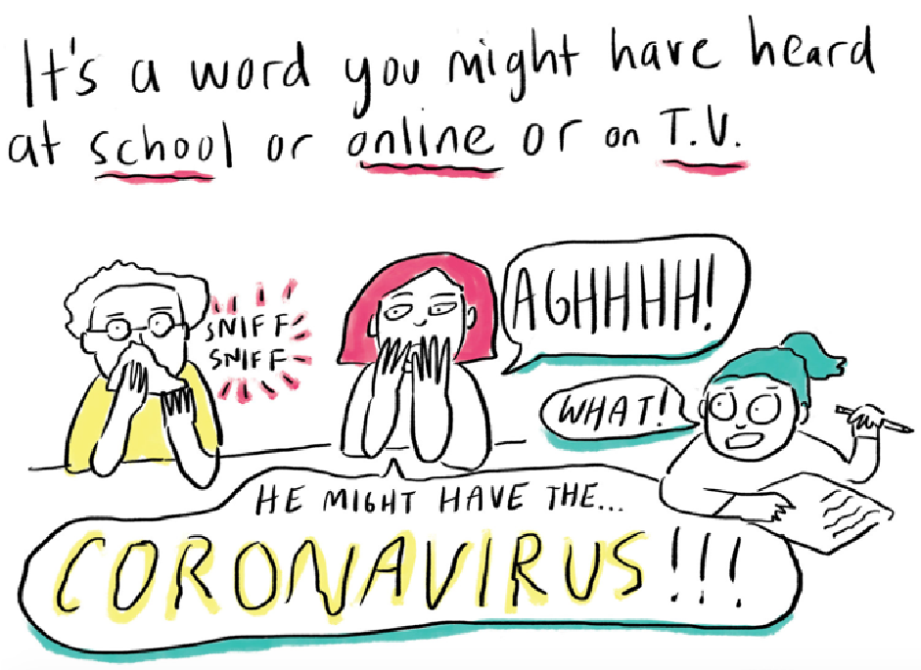

https://www.npr.org/sections/goatsandso
da/2020/02/28/809580453/just-for-kids a-comic-exploring-the-new coronavirus?t=1584457518291

For school aged children BBC’s Newsround has a COVID-19 website featuring a range of stories and videos on the outbreak:
https://www.bbc.co.uk/newsround/51204 456

These include:
Facts and Myth-busting

https://www.bbc.co.uk/newsround/51387
017

Newsround advice on how to manage worries about COVID-19
https://www.bbc.co.uk/newsround/51911 025

For older young people
The World Health Organisation has released this video containing facts about COVID-19 and ways in which the spread can be prevented:
https://www.youtube.com/watch?v=mOV 1aBVYKGA&t=216s

The Centre for Disease Control has produced a 1-page COVID-19 fact sheet:
https://www.cdc.gov/coronavirus/2019 ncov/about/share-facts-h.pdf

Help your child to be able to feel in control where they can (and highlight why that is good for others too)
E.g. “There are lots of things that we can do to protect ourselves and help other people, like washing our hands, and offering to buy groceries for people.”
Some of the resources above give useful childfriendly information on keeping ourselves and others safe.

Be clear about the limits of children’s responsibilities
Let children know that the government, the health service, scientists and many others are working very hard to keep people safe. That is their job. There are some specific resources at the end of this document for when people experience problems with obsessions or compulsions (where it is particularly common to people to feel responsible for something bad happening, like passing on germs to other people or getting sick themselves).

Highlight the good things
Whilst it is a genuinely challenging time, do help children to recognise the positive things that are happening. E.g. “There are lots of people working hard to keep us all safe, for example the doctors and nurses at the hospital, the scientists finding a vaccine, and even us by washing our hands!” Point out the amazing community organisations that have formed and other actions people are taking to help each other.

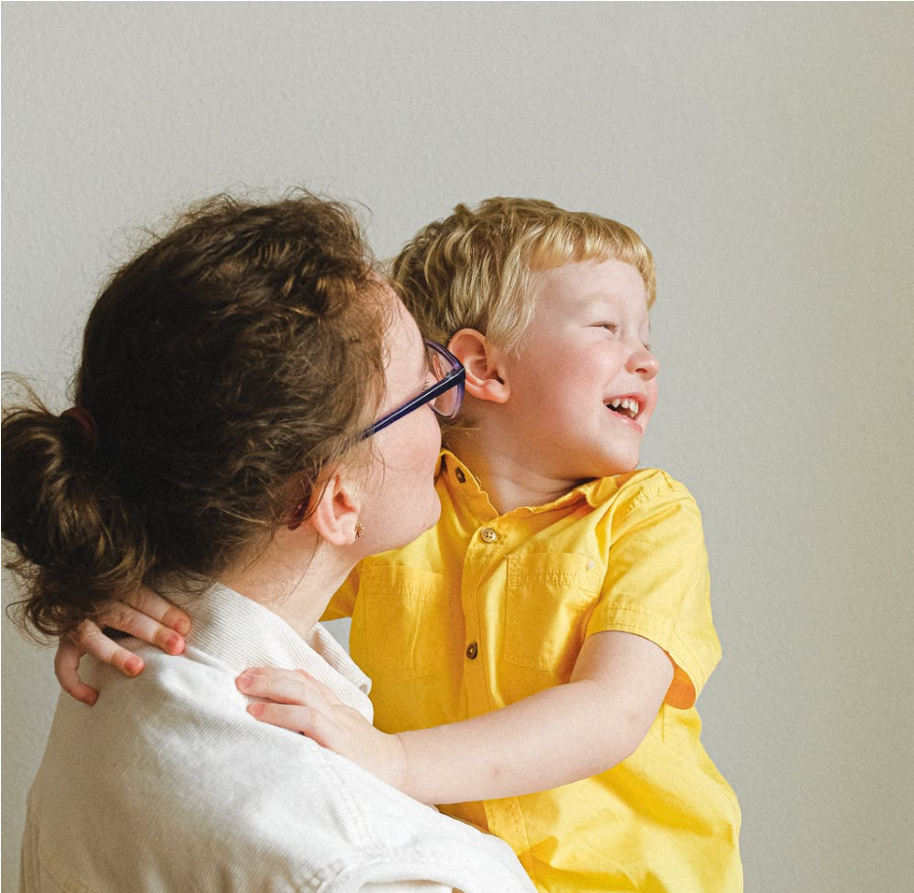

Find ways to deal with worries
It can be easy for every waking hour to be dominated by worry, particularly with the constant access we have to news. Limit children’s unsupervised exposure to the news. For example, you could introduce a “news time” when you look at it or listen to it together and discuss what comes up. For older children, if they are getting unhelpful information via social media, then could they experiment with limiting how much time they spend on it or what they look at? If they are talking to friends about it a lot, could they limit these conversations and instead try to talk about other things?
Help children and young people to think about whether the worry is something they can do anything about, or not. If it is not something that is under their control it will be important to gradually learn to tolerate that worry and focus on other things. This is obviously a tricky thing to do, but one way to help children feel confident that their worries will be dealt with, and also get in to practice of keeping them under control, is to introduce a “worry time” where you agree a time each day where you can sit down for a certain amount of time (max 30 minutes) and talk through the worries in turn. Your job is mostly to listen and empathise.

When children and young people start to worry outside of “worry time” ask them to record their worry and assure them it will be addressed at “worry time”. This can also help children notice that sometimes things that seem like big worries, don’t seem such a problem after some time has passed.

Take practical steps to feel less worried
Earlier on, we talked about the vicious cycle of anxiety and that some behaviours that seem helpful can end up making the problem worse. We’ve talked about ways to deal with the worries. Also look out for behaviours like checking, being on the alert for danger or washing hands in a way that goes beyond the medical advice. Encourage the child or young person to experiment by reducing these behaviours – perhaps in line with what a trusted friend might do? What would their friend recommend in terms of how they wash their hands or the amount of time they spend in their head thinking about this all? Sometimes there might be some practical steps children and young people can take. For example, if worries relate to others (e.g., grandparents or a friend with a underlying physical health condition), encourage them to do things that make them feel more connected to those people when they are not able to see them in person, e.g., texting, phoning, using skype/facetime, writing a note, making a card, sending them something through the post.

Where anxiety is persistent and getting in the way of life

Inevitably some children and young people will find this more difficult to deal with than others. Some young people may already be struggling with anxiety difficulties and the current situation may have exacerbated preexisting worries. If you are concerned about a child or young person and their anxiety is persistent and getting in the way of their lives (e.g., their sleep, schoolwork, friendships or family life), then they might need some professional help. Your GP will be able to advise further.

Other Helpful Resources:

Talking to children about COVID19

To read:
UNICEF’s 8 quick tips for talking to children about COVID-19

https://www.unicef.org/coronavirus/how-
The talk-yourFlourishing -child-aboutFamilies -coronavirusClinic- covid(at - the
University of Sussex and Sussex Partnership 19 NHS Trust) has produced some tips and advice on how to talk to your child about their COVID19 anxieties

https://www.flourishingfamiliesclinic.nhs.

uk/How%20to%20Talk%20to%20Children

%20about%20COVID.pdf

The National Association of School Psychologists have produced a resource for parents for talking to children about COVID-19
anxieties

https://www.nasponline.org/resources and-publications/resources-and podcasts/school-climate-safety-and crisis/health-crisis-resources/talking-to children-about-covid-19-(coronavirus)-a parent-resource

Wandering Minds of a Psychologist explains why it is important to talk to children about COVID-19 and provides concrete examples of
things to say/ questions to ask

https://wanderingmindofapsychologist.co m/2020/03/06/how-to-talk-to-kids-about-
coronavirus/amp/?__twitter_impression=t rue

The Guardian has published providing advice on both how to talk to your child about COVID-
19, and what to cover

https://www.theguardian.com/commentis free/2020/mar/02/stop-a-worry becoming-catastrophic-how-to-talk-to your-kids-about-the-coronavirus

To watch:
BBC Radio 4’s Women’s hour covered a discussion about how to talk to children about COVID-19
https://www.bbc.co.uk/sounds/play/p085
rjkm

This Vimeo provides tips and advice about how to talk to your child about natural disasters and news events
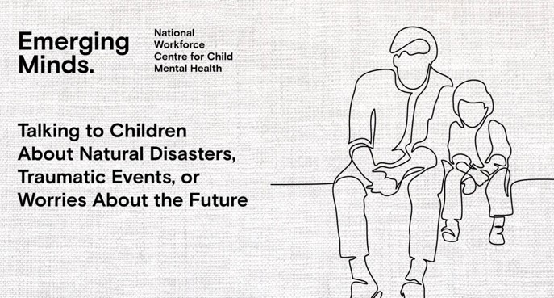
https://vimeo.com/394049129

Dr. Ehrenreich-May is a child psychologist who has produced a Vimeo outlining three tips for talking to your child about COVID-19
https://vimeo.com/398065042?ref=tw share
The Child’s Mind Institute has published a video providing advice on talking to children about COVID-19
https://childmind.org/article/talking-to kids-about-the-coronavirus/

Resources for teachers and others working with children
The National Association of School
Psychologists has a resource preparing mental health professionals in schools for infectious disease epidemics and outbreaks
https://www.nasponline.org/resources and-publications/resources-and-
podcasts/school-climate-safety-and-
crisis/health-crisis-resources/preparing for-infectious-disease-epidemics-brief-
tips-for-school-mental-health-
professionals

UNICEF has published advice for teachers
https://www.unicef.org/coronavirus/how teachers-can-talk-children-about-
coronavirus-disease-covid-19

The Centre for Disease Control’s general principles for parents, teachers and any other professionals working with children
https://www.cdc.gov/coronavirus/2019 ncov/community/schools-
childcare/talking-with-children.html

The British Psychological Society have published some tips talking to children about COVID-19 concerns. It refers to “your child” but the tips and strategies are the same for any adults working with children, not just parents
https://www.bps.org.uk/news-and-
policy/bps-highlights-importance-talkingchildren-about-coronavirus

Resources for children and young people with specific needs
Helpful tips on managing OCD symptoms and dealing with handwashing during outbreak from OCD-UK (aimed at adults but also
suitable for teenagers)
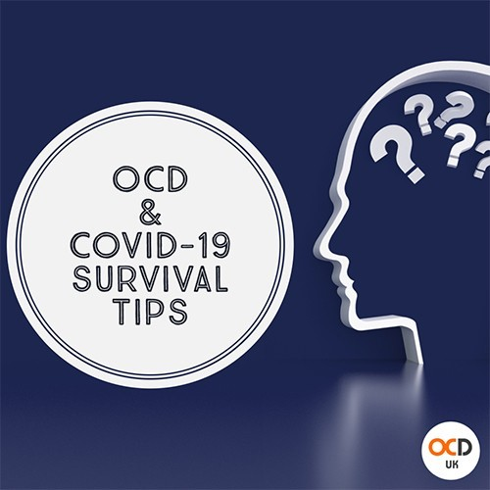

https://www.ocduk.org/ocd-and-
coronavirus-survival-tips/

The international OCD foundation has published advice for parents of youth with OCD
https://iocdf.org/covid19/talking-to-kids about-covid-19/
Additude has published some advice for parents of children with ADHD
https://www.additudemag.com/explaincoronavirus-covid-19-anxiety-adhd-child/ Anna Kennedy Online has provided some
advice for parents of children with ASC
https://www.annakennedyonline.com/aut
ism -and-coronavirus-advice-for-parentsby-rosie-weldon/

Advice for reducing the impact of routine disruption for those with ASC
https://themighty.com/2020/03/covid-19 autism-routine-disruption/

Social story about COVID-19
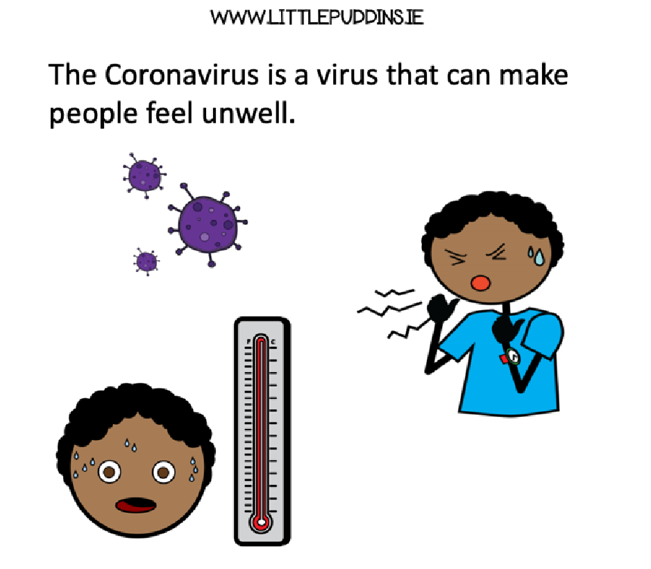
https://theautismeducator.ie/wp content/uploads/2020/03/The-CoronaVirus-Free-Printable-.pdf

Mencap easy-read
https://www.mencap.org.uk/sites/default
/files/2020-
03/Information%20about%20Coronavirus
%20ER%20UPDATED%20130320%20SD%2
0editsAH.pdf

General information about helping children manage anxiety
Creswell, C. & Willetts, L. (2019). Helping Your Child with Fears and Worries, 2nd Edition. London: LittleBrown.

This is a book for parents about how they can help their anxious child and includes lots of tried and tested strategies.

Self-isolating
Dr. Ehrenreich-May has produced a Vimeo on dealing with strong emotions when self-
isolating with children
https://vimeo.com/398401539

BBC Bitesize advice on learning at home
https://www.bbc.co.uk/teach/five-ways-
to-keep-your-kids-learning-at-

home/z4966v4

BBC Bitesize has a range of home education
activities
https://www.bbc.co.uk/teach

10 indoor activities for children if self-isolating
https://www.babygaga.com/coronavirus self-isolation-quarantine-activities-for kids/

