**LOCKDOWN**

**Newsletter**

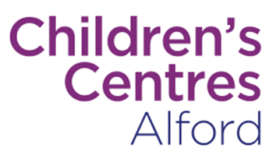

Lincolnshire

**May 2020**



**Issue 1**

## Useful information



**Child Safety During Lockdown**

Our hands and homes have never been so clean. But doctors are worried that young children stuck at home during lockdown may be at higher risk from an abundance of potentially poisonous things.

From sanitiser to surface spray, paracetamol to pods, the steps to stop poisoning are simple. We share our top tips on keeping children out of harm’s way.

Preventing Poisoning during Lockdown useful resources:

[Preventing Poisoning](https://www.capt.org.uk/poisoning-essential-facts?mc_cid=705cea1135&mc_eid=7805ac5bfb)

Lots of downloadable top tips resources can be found here:

[Child Safety Top Tips Resources](https://www.capt.org.uk/top-tips-lockdown?mc_cid=705cea1135&mc_eid=7805ac5bfb)



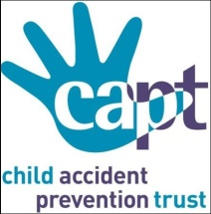





**Mental Health Awareness**

The Virtual Night Light cafe is continuing to offer support to those who are struggling with their mental health during the Covid-19 lockdown period.

This service is supported by City of Lincoln and runs between 7pm and 10pm

Monday - Friday and is offered to those over the age of 18.

To refer someone to this service, please complete the referral form here:

[Referral Form](https://forms.gle/vhtB58L3UqdSZVCv7)

**Starting School September?**

Louis' Top Tips for starting school No.1

'I can try to independently undress and dress myself and unfasten and fasten my shoes'

Choose coats and shoes with easier fastenings such as velcro and zips rather than buttons and laces.

Teach your child how to turn their sleeves and tights/trouser legs the right way round when they are inside out.

Try the flip trick to help them put on their coat independently. Watch it here …

<https://www.youtube.com/watch?v=UUHmveYYOrw>

**Volunteering**

Lots of people are Volunteering at the moment. When we are back to ‘normal’ again and children are back in Nursery or school you may want to have a go at Volunteering for a cause you would like to support. You could start looking into this now to get a few ideas - check out <https://do-it.org/>

**Career Pathways**

In lockdown you may have more ‘thinking time’ than usual. You may have thought about a job you could do, but need advice about how to be ready for it. The National Careers Service has advisors available to speak to by phone or webchat.  They offer free and impartial information, advice and guidance to support you in achieving your work goals. You can call them on 0800 100 900 or visit their website to contact them via webchat

<https://nationalcareers.service.gov.uk/about-us>

It could be the start!

 

**Adult Learning**

It’s still possible to continue to learn at this unsettling time.

Completing one of the webinars listed below may even help with managing stress, boredom or anxiety, as well as being brilliant for personal development on a CV.

Perhaps the courses below spark an interest:

* Mindfulness for managing stress
* CV writing & interview skills
* Assertiveness & Confidence building

To book on to the webinars above and much more visit the link below

<https://www.rhgconsult.co.uk/courses/personal-improvement-business-development>

**Dental Health**

Access to NHS Dentistry is currently limited during the pandemic as dentists have been asked to stop all routine “face-to-face” dental care.

However, if you need urgent dental care, help is at hand:



**Do not worry if you have COVID-19 symptoms,**

**appropriate arrangements**

**can be made to see you if you need**

**urgent dental care.**

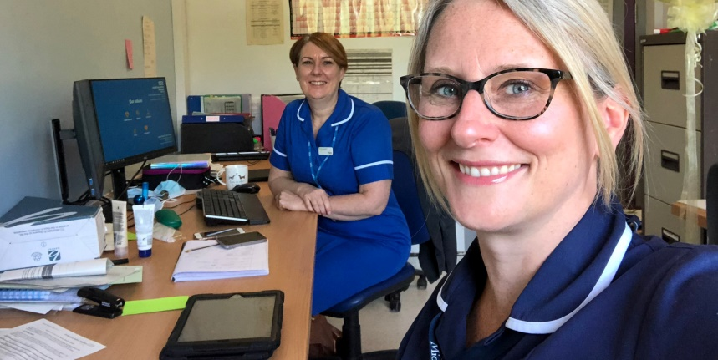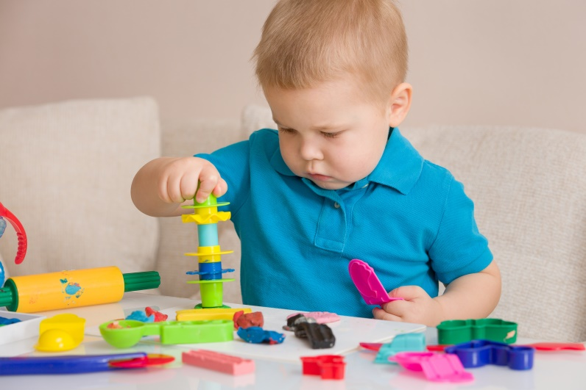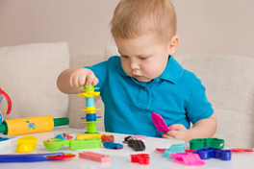



**Early Years Alliance**

Have you seen one of the Early Years Alliance Webinar or YouTube broadcasts? What about our Zoom sessions? Has your Early Years Educator been in touch?

If so, we would love to hear from you! Please take our survey to help us gauge feedback on the virtual sessions and home learning support we are offering during this time:

[EYA - Feedback Survey](https://www.surveymonkey.co.uk/r/best-start)

**Pregnancy News**

Congratulations on enhancing the digital offer

Specialist midwife for IT, Lorri Allport, at ULHT looks at how technology has helped support women through pregnancy, birth and post-natal care in rural Lincolnshire during the COVID 19 pandemic

Read her blog here:

[Lori Allport - Birth in a time of Solitude](https://digital.nhs.uk/blog/transformation-blog/2020/birth-in-a-time-of-solitude?fbclid=IwAR3b6AKje8LHthm7wrXDJJIQHAoOqQe4oEHAFh3jJx0GN79XU67cyvUc2kY)

Follow us on Facebook -Better Births Lincolnshire, Twitter @betterbirthlinc and on our website <http://www.betterbirthlincolnshire.co.uk>

**Facebook**

Please remember to head over to our Facebook pages for regular updates whilst our Children's Centres are closed. There are daily posts signposting families to our virtual sessions we and useful ideas to keep you and your little ones busy during this time.